1

Execute “**top -c -n1|grep java**” to get PID of JAVA and location of “bin” directory of JRE as below. We had 6319 as PID of JAVA and /usr/java/sapjvm_7/jre/bin as “bin” directory of JRE here.



2

Execute “**top -n1 -Hp[$pid]|grep -v 0:**” to get informations of all subprocesses to get the exact subprocess we are suspecting.

H: Show threads

P: Specify PID of parent process which we are monitoring (got from step 1).

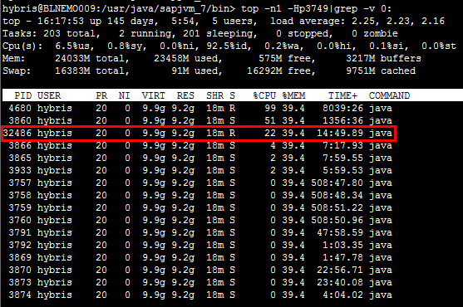

3

Execute “**printf “%x\n” [$subpid]**” to get hexadecimal of PID of subprocess got from step 2.



4

Switch prompt to the location of “bin” directory as we had at step 1 if there is no “$JAVA_HOME/bin” is specified to PATH as Environment Variables.



5

Execute “**jstack [$pid]|grep -A50 [hexadecimal of [$subpid]]**” to get detail of stack of the subprocess we suspected at step 2.

Command line must start with “./” if prompt is currently at the location of “bin” directory and no “$JAVA_HOME/bin” is specified to PATH as Environment Variables, for instance: “**./jstack [$pid]|grep -A50 [hexadecimal of [$subpid]]**”.

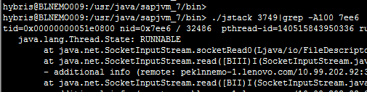

6

According to stack detail, we can directly troubleshoot the issue that line 351 in “UpdateMinimumProductPrice.java” is slowly running. And finally we can find out that line 68 in “AbstractValidator.java” is causing the performance issue. Next we can optimize program purposefully.

